

Written Submission for the
Pre-Budget Consultations in advance of the
Upcoming Federal Budget
May 22, 2026

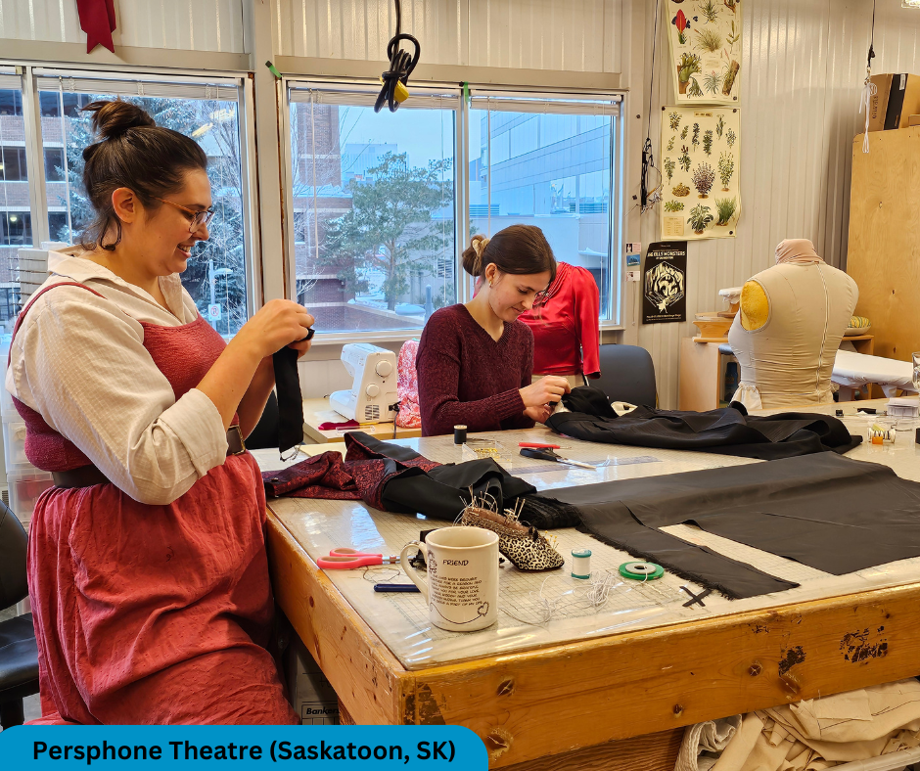

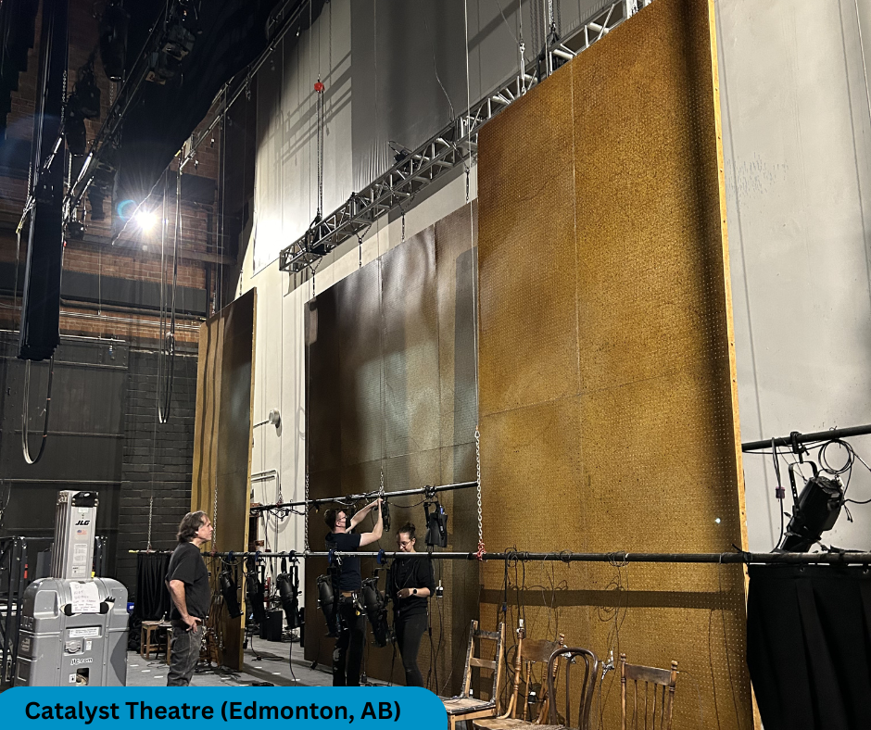

RECOMMENDATIONS

As our nation prepares to celebrate its 160th anniversary next year, investing in our creative industries is key to building a strong Canada for all.

- Recommendation 1: That the Government of Canada implement the Canadian Live Performing Arts Accelerator, a labour-based tax credit for performing arts organizations to increase employment, cultural sovereignty, and economic growth in the Canadian live performing arts industry.
- Recommendation 2: That the Government of Canada provide an additional $140 million annual investment to the Canada Council for the Arts, starting in the 2026-27 fiscal year, to stabilize and strengthen Canada’s arts sector.

- Recommendation 3: That the Government of Canada prioritize cultural infrastructure funding within the Build Communities Strong Fund to support cultural infrastructure construction, renovation, replacement, and retrofits.

INTRODUCTION
The Professional Association of Canadian Theatres (PACT) is the collective voice of professional Canadian theatres, a leader in the performing arts community, and a devoted advocate of the value of live performance in communities across Canada. We represent over 180 professional English theatre companies, ranging from the largest performing arts organizations in Canada to smaller theatre companies that serve their audiences from coast to coast to coast. Through innovation and transformation, our resilient sector is welcoming new and returning audiences in growing numbers.
The recommendations outlined below are not PACT’s alone. We echo those from the sector, across regions and disciplines. Canada’s artists, cultural workers, and arts organizations are stepping up and have a clearly defined role in building a culturally sovereign and economically vibrant Canada for all.

THEATRE AS ECONOMIC AND CIVIC CATALYST

In the face of economic pressure and global uncertainty, Canada’s cultural sector, and theatres in particular, are vital to achieving the priorities outlined in the Prime Minister’s mandate letter. Building a sovereign and affordable Canada is not possible without sustained investment in the institutions that foster belonging, resilience, and innovation. Theatres sit at the heart of that mission.

Canadian theatres are uniquely positioned to build belonging. With the Canada Strong Pass, the Government has recognized how culture and nature are key to how Canadians feel connected to their nation. This is underscored by reports that 80% of new Canadians felt an increased sense of belonging thanks to recreational and cultural engagement. The percentage of culture-goers reporting a stronger sense of belonging to Canada climbed significantly this year, reaching 75% in the August 2025 Arts Response Tracking Survey produced by Business / Arts and Nanos Research. Similarly, PACT has found that 94% of Canadians believe that theatres make their community a better place to live.
Belonging and sovereignty are not abstract concepts for theatres – it is the ability to tell our own stories, to see ourselves reflected in our public spaces, languages, and narratives. In 2025 alone, over 5,000 Canadian works were performed in theatres nationwide, including 2,484 new works. Last year, Canadian theatres presented over 36,000 public theatre events and activities. Beyond staff and artists, these activities were supported by 25,000 theatre volunteers. We believe there is no greater indicator of the value Canadians place on the performing arts than the hours donated by their fellow Canadians.

The theatre sector is also a job creator and a catalyst for local economies. In 2025, theatres provided well-paying positions for over 35,000 technicians, production personnel, performers, and arts workers. For every one job on stage, there are seven jobs backstage, and nine jobs out in the community - restaurants, hotels, and vendors - whose livelihoods are reliant on the success of their local stages.

Yet despite this proven value, theatres and the cultural sector are often overlooked as essential elements of a successful economic growth strategy. As such, we recommend a reliable, scalable metric for ensuring that culture remains a pillar of national policy, one proportional to the public value it creates.
RECOMMENDATION 1

The Government of Canada implement the Canadian Live Performing Arts Accelerator, a labour-based tax credit for performing arts organizations to increase employment, cultural sovereignty, and economic growth in the Canadian live performing arts industry.
Nation-building is not done through infrastructure alone. Imagine unlocking the full impact of Canada’s live performing arts sector, where show business is big business in Canada’s changing economy. The voices of our Canadian artists, the talents of our cultural workers, and the creativity of our arts organizations are incredible assets which can be leveraged to both stimulate the economy and highlight our cultural sovereignty.

The Live Performing Arts Accelerator (LPAA) is a time-limited injection that would offer both eligible non-profit and commercial organizations a 25% tax credit rebate on Canadian production-related labour expenses (up to a capped amount), provided that organizations commit to reinvesting the rebate in more Canadian productions within 12-months of receipt.

This is a clear, simple, and targeted measure that is responsive to market forces. It provides a reliable and predictable program which leverages the private sector to directly reinforce and promote Canadian investment in Canadian workers. Further, it responds directly to the objectives of the Canadian government to build economic resilience as we strive to meet our stated ambition to be the strongest economy in the G7, while protecting our unique Canadian cultural identity, and ensuring Canadian artists can compete on the global stage.

Fulfilling Mandate Letter Priorities

1) Strongest Economy in the G7

In the mid-1990’s, the Canadian government implemented the Canadian Film or Video Production Tax Credit and turned a struggling market into a $12 billion industry, earning the global nickname “Hollywood North”. With a 30-year track record here at home, now is the time to replicate that success on our stages.

National modeling using Statistics Canada data shows the LPAA would generate $23 dollars of economic impact for every $1 of investment. Case in point, theatres are catalysts in downtown revitalization efforts across Canada, with restaurants and businesses reporting an 18% increase in sales on performance days, bolstering patron traffic and reinforcing behaviours for other downtown festivals and events.

Similar systems already exist across the UK, France, and several US states, and Australia will launch a program in the coming months. Canada is losing talent, revenue, programming opportunities, and capital investments to these other jurisdictions. Based on a UK study of their Tax Relief program, additional private investment was attracted at a ratio of 1:4 to government investment; comparable Canadian numbers would attract $1.71B.

2) Helping Canadians Get Ahead

The best way to support Canadian artists is to provide more work. With the predictability of LPAA, organizations can effectively scale and respond to market demands. For example, following the successful run of a new work, organizations would have the flexibility to extend the run, thereby maximizing Canadian viewership, selling further tickets, and retaining often hundreds of individual artists and cultural workers for additional weeks of work. In an affordability crisis, increased product availability and competition will reduce ticket prices, ensuring more Canadians can afford to see their favourite Canadian performers. Further, this maximizes work opportunities for cultural workers and artists, who face disproportionate employment precarity.

A recent survey conducted by Hill Strategies Research for the Cultural Human Resources Council found that 51% of artists earn under $40,000 annually, with 69% experiencing financial stress. For Equity-deserving artists, that number climbs to 85%.

In the live creative industries, every new show equals new Canadian jobs, such as backstage technicians, carpenters, costume designers, musicians, stage managers, and performers. It also means more jobs, shifts, and opportunities for auxiliary workers in the restaurant, tourism, and hospitality businesses. An LPAA will generate 45,312 new employment opportunities and inject an additional $9.2 billion of economic activity across communities and sectors over the next three years.

3) Protecting Canadian Sovereignty

In a typical year, 1-in-4 Canadians attend the theatre. Local theatres are touchpoints for connection and discovery, promoting cohesion and civic engagement across Canada. And at a time of increased feelings of separation and loneliness, we need more theatre. Whether it be an outdoor festival, an annual holiday favourite, or a thrilling new Canadian work, Canadian theatres provide a constant in our cultural landscape. They are also a space where we may truly participate in supporting cultural sovereignty, discovering new stories, perspectives, and ideas about what it means to be Canadians.

A national program would mean a more connected country. Uneven provincial and territorial cultural funding programs and regional policy discrepancies (such as SODEC in Quebec) create a disjointed and unreliable marketplace. A clear, reliable, national program would foster interprovincial touring, business development, and exchanges, bringing communities closer to their favourite artists.

However, cultural sovereignty does not only mean creating Canadian stories for Canadian audiences. Canadian theatre-makers are globally respected innovators and leaders in their field, transforming business models. With the LPAA, organizations would be able to restore and increase touring capacity, attracting international investment, while playing a diplomatic role abroad, furthering both financial and cultural investment in Canadian art forms.

RECOMMENDATION 2

That the Government of Canada provide an additional $140 million annual investment to the Canada Council for the Arts, starting in the 2026-27 fiscal year, to stabilize and strengthen Canada’s arts sector.

The Canada Council for the Arts is the primary federal instrument for supporting artistic creation and public access to arts across the country. For theatres and performing arts organizations, Canada Council funding is a foundational operating investment that allows for planning seasons, hiring artists, technical workers and arts administrators, commissioning new Canadian work, and developing community programming.

New investment is urgently needed. Public investment has not kept pace with increased costs nor demand, and as such the Canada Council is facing significant pressure on its core granting programs, creating uncertainty for organizations that depend on stable federal support. For theatres, that is especially concerning. An estimated 78% of theatres rely on Canada Council core funding, meaning that reductions or stagnation in Council support have immediate consequences for programming, employment, touring, audience access, and the long-term sustainability of the sector.

A permanent increase to the Canada Council would provide a direct, targeted and high impact investment in the organizations that are the backbone of Canada’s cultural ecosystem. It would help address regional inequity, rising operating costs, environmental impacts, and weakened private and philanthropic support. Support for the Canada Council for the Arts is the cornerstone of advancing Canadian sovereignty, by supporting the very artists and organizations that give it voice.

The economic case is also clear. Canada Council investment delivers strong return, with every dollar the Council invests in core-funded organizations contributing $5.75 to the economy. Increasing the Council’s budget would therefore not only stabilize arts organizations, but also generate broader economic activity through employment, local spending, tourism, cultural production and community development, and ensure that Canadians in communities of all sizes continue to have access to professional theatre and cultural experiences.

RECOMMENDATION 3:

That the Government of Canada prioritize cultural infrastructure funding within the Build Communities Strong Fund to support cultural infrastructure construction, renovation, replacement, and retrofits.

For many years, the Canada Cultural Spaces Fund (CCSF) has been a lifeline for theatres seeking support for cultural infrastructure construction, renovation, replacement, and retrofits. With their unique understanding of our business models, Cultural Spaces existed as the only infrastructure avenue for many aging civic venues. In Budget 2025, the funding envelope for the CCSF was reduced and reoriented to focus on specialized equipment in the cultural sector.

With the recent announcement of the Build Communities Strong Fund (BCSF), cultural initiatives of all sizes now must compete with a multitude of civic and industry infrastructure projects, limiting the potential for success. Amidst a department that does not have insights into our unique sector, we are concerned that important cultural community projects will be missed.

We recommend that the Build Communities Strong Fund work with the Department of Heritage to prioritize cultural infrastructure funding to support cultural infrastructure construction, renovation, replacement, and retrofits.

Brad Lepp, Executive Director
PACT
BradL@PACT.ca
250 The Esplanade, Suite 307, Toronto, ON. M5A 1J2
PACT.ca

